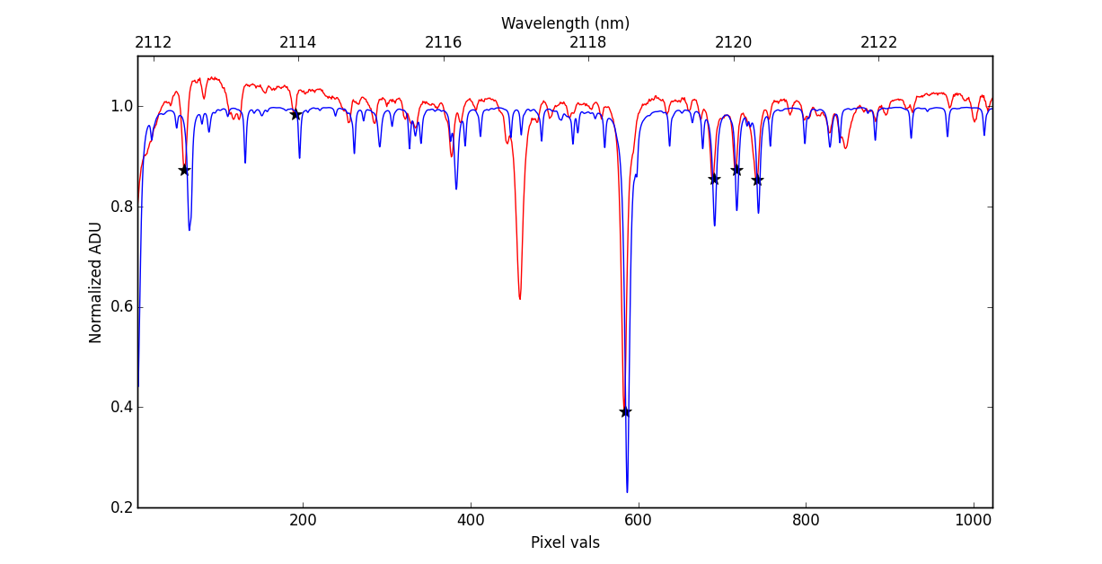

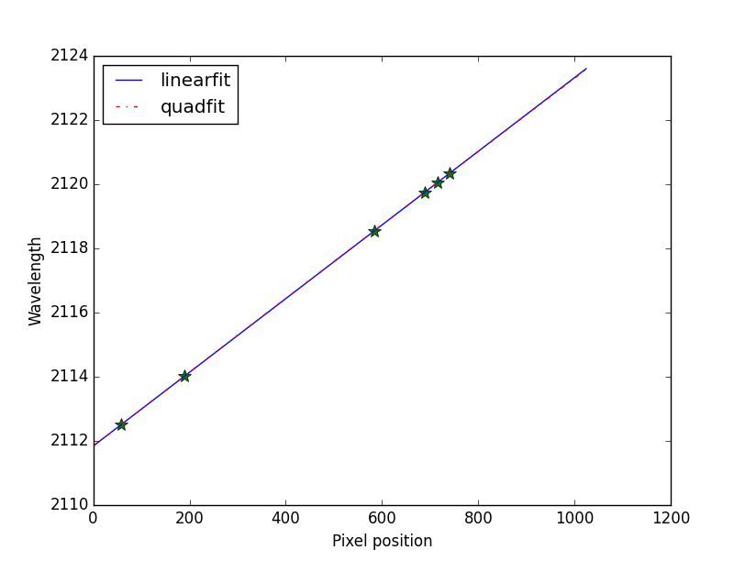
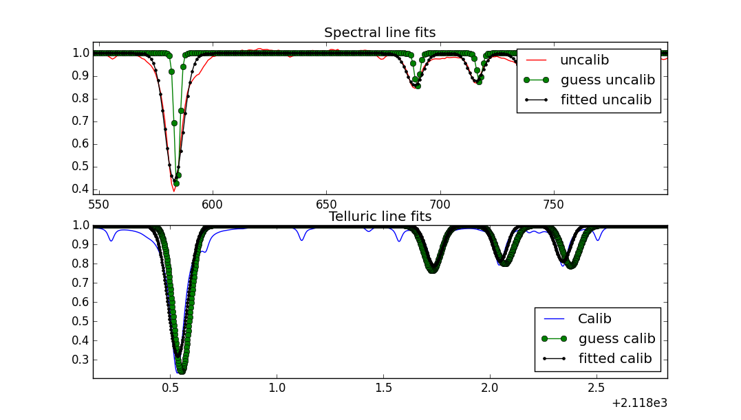
Line Selection

Guess lines and Fitted lines

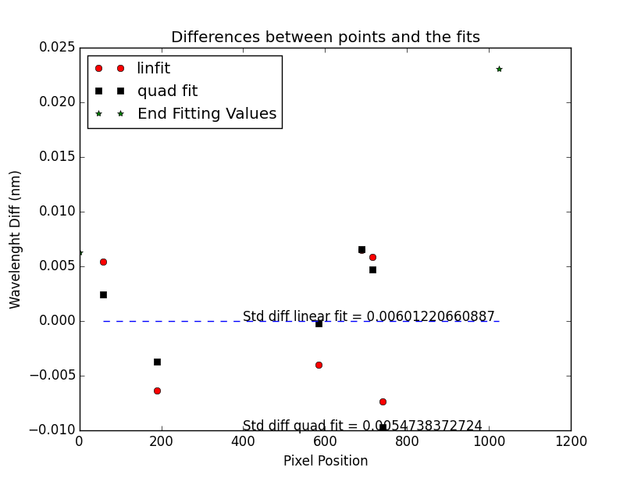

Wavelength differences between map points and fitted lines. End values show the deviation at end of spectra w/o any close lines

Pixel map fitting

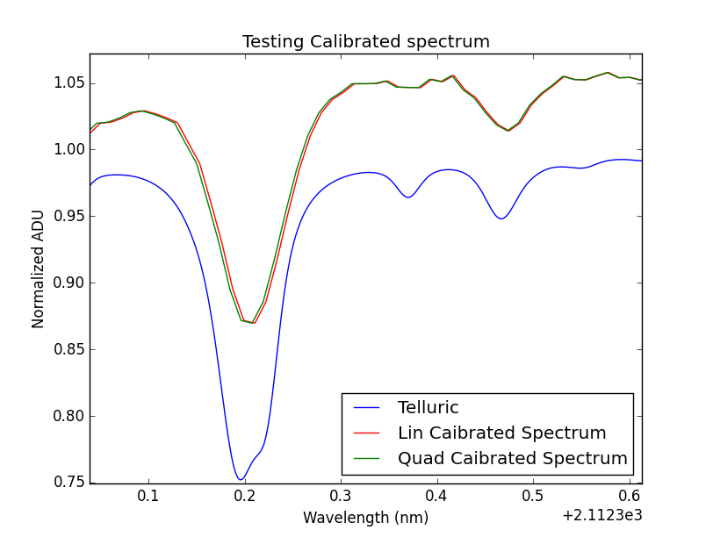
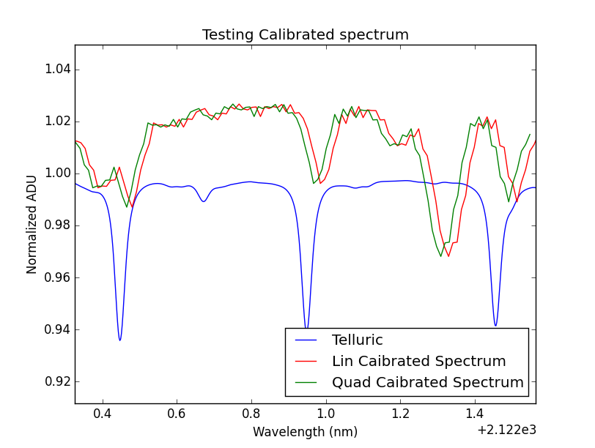
Right side of calibrated spectra
(lin fit on left)

Left side of calibrated spectra
(lin fit on left)

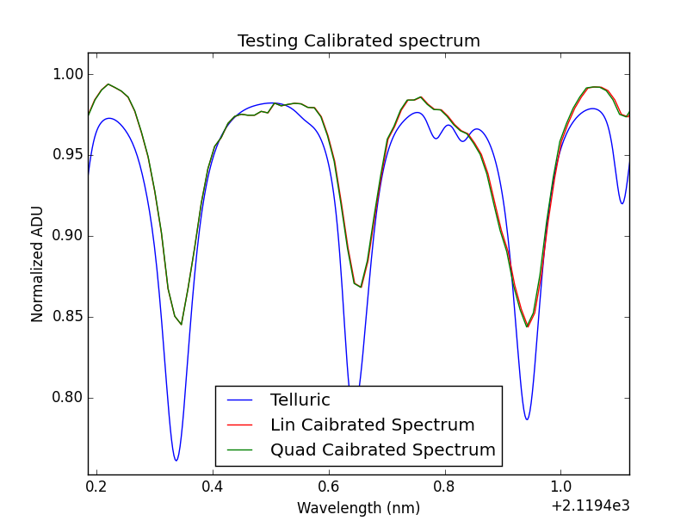

Middle of calibrated spectra

